**Nama : Adinda Fauzatus Azizah**

**NIM : 10201001**

**Kelas : Pemrograman Terstruktur A**

1. Mencari nilai 8 dalam array

|  |  |
| --- | --- |
| No. |  |
| 1  2  3  4  5  6  7  8  9  10  11  12  13  14  15  16  17  18  19  20  21  22  23  24  25  26  27  28  29  30  31  32  33  34  35  36  37  38  39  40  41  42  43 | #include <stdio.h>  #include <iostream>  #include <conio.h>  using namespace std;  int A[10] = {12,24,13,25,8,11,21,12,8,18};  int bil, a, b;  void cari (int bil)  {  for (a = 0; a < 10; a++)  {  if (A[a] == bil)  {  cout << "Bilangan yang anda cari berada di indeks ke - " << a << endl;  break;  }  }  getch ();  }  int main()  {  for (int i = 0; i < 10; i++)  {  cout << "Indeks - [" << i << "]" << " " << A[i] << endl;  }  cout << endl;    cout << "Masukan bilangan yang akan dicari : ";  cin >> bil;    cari (bil);  for (a = 0; a < 10; a++)  {  if (A[a] != bil)  {  cout << "Bilangan yang dicari tidak terdaftar";  break;  }  }  return 0;  } |

Output:

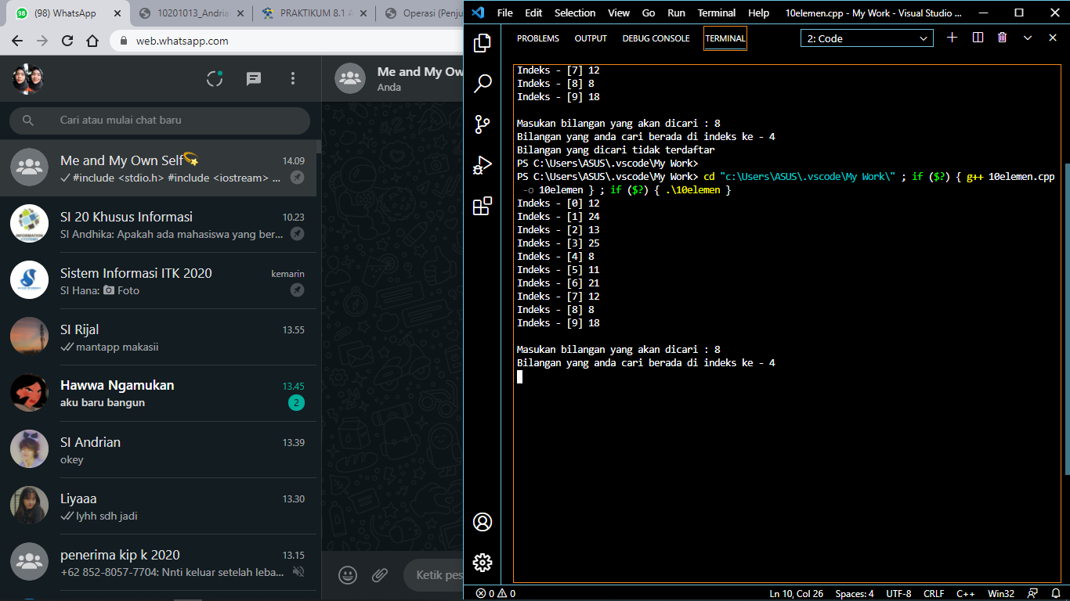

2. Perkalian antar matriks

|  |  |
| --- | --- |
| No. |  |
| 1  2  3  4  5  6  7  8  9  10  11  12  13  14  15  16  17  18  19  20  21  22  23  24  25  26  27  28  29  30  31  32  33  34  35  36  37  38  39  40  41  42  43  44  45  46  47  48  49  50  51  52  53  54 | #include <iostream>  using namespace std;  int main()  {  int matriks[2][2], hasil[2][2];  int a, b, c;  cout << "Program Perkalian Matriks, silakan input elemen" << endl;  for (a=0;a<2;a++ )  {  for (b=0;b<2;b++)  {  cout << "A[" << a << "][" << b << "] = ";  cin >> matriks[a][b];  }  }  cout << "Matriks A : " << endl;  for (a=0;a<2;a++)  {  for (b=0;b<2;b++)  {  cout << matriks[a][b]<<" ";  }  cout << endl;  }  for (a=0;a<2;a++ )  {  hasil [a][b] = 0;  for (b=0;b<2;b++)  {  c = matriks[a][b]*5;  hasil[a][b] = c;  }  }  cout << "Hasil perkalian matriks dengan 5 : " << endl;  for (a=0;a<2;a++)  {  for (b=0;b<2;b++)  {  cout << hasil[a][b]<<" ";  }  cout << endl;  }  cout << endl;  return 0;  } |

Output :

